Slug Bus Schedule: User Manual

Use the link:

Link: [https://slug-bus-schedule.azurewebsites.net](https://slug-bus-schedule.azurewebsites.net/) to open the app

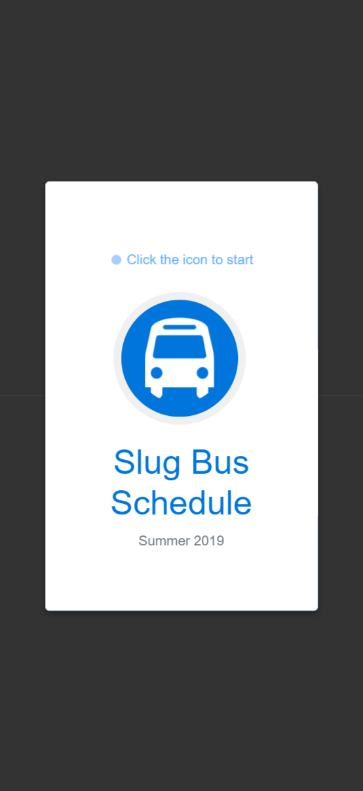

Click to start

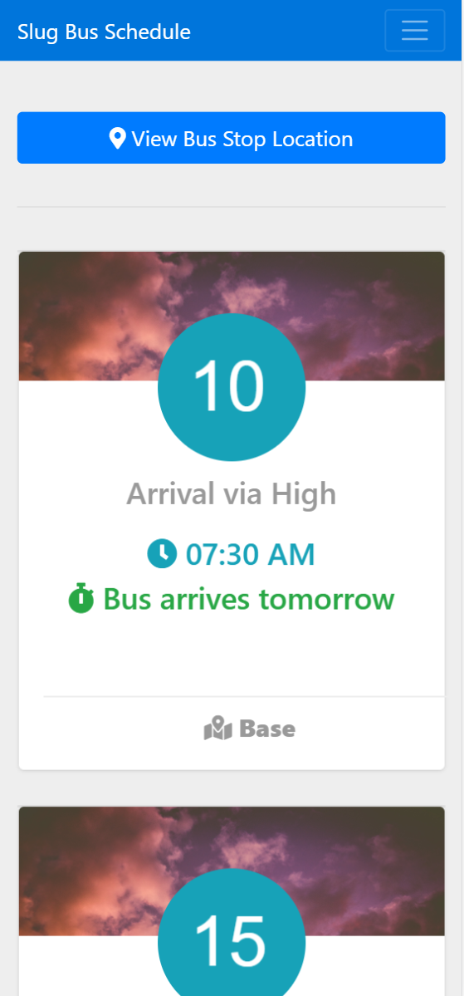

Click to report crowdedness

See the map